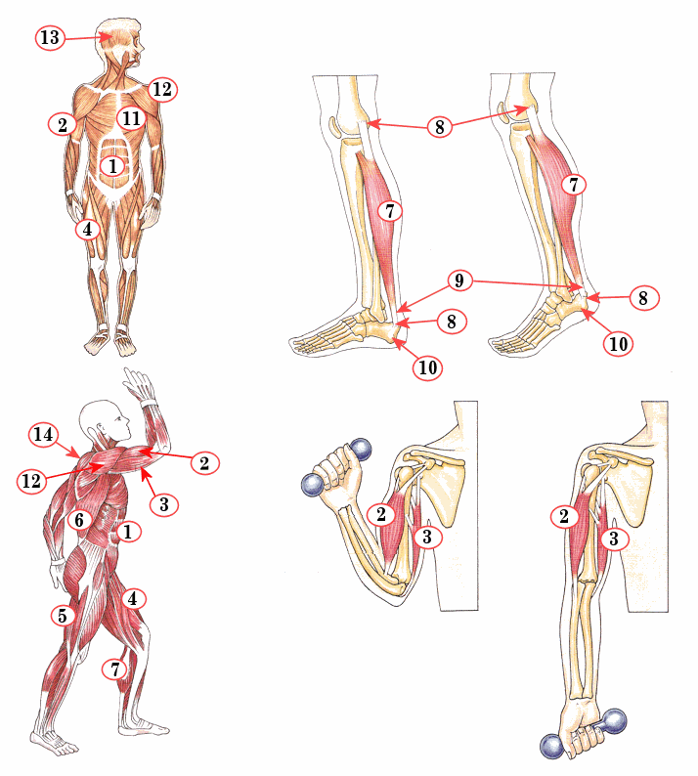

|  |  |  |
| --- | --- | --- |
| Nummer | Naam spier | Antagonist van? |
|  |  |  |
|  |  |  |
|  |  |  |
|  |  |  |
|  |  |  |
|  |  |  |
|  |  |  |
|  |  |  |
|  |  |  |
|  |  |  |
|  |  |  |
|  |  |  |
|  |  |  |
|  |  |  |